

Hackathon 2016

The 2016 Growth Innovation Challenge



Aula

By

Team : **Half Baked**

**Aula - Real classroom experience**

**Problem**

Around the globe, we have many online educational services offering several online courses with or without tutors to learners based on their preferences. Learner who consumes the video offline misses the experience of the real classroom. Learning is incomplete and unsatisfactory in the majority of learning solutions.

**Solution**

So the missing piece here is, real classroom experience. To make learning more engaging and interesting we've blended Virtual reality with distance & digital learning system. Classes will be recorded/online streamed with 360-degree video camera and projected to a mobile app subscribed by learners. Learner will be provided with a VR box (Similar to Google Cardboard - costs less than $15).

* Learner opens the mobile app Aula
* Wears his VR box
* He can experience the real experience classroom around him.

**Business Impact**

* Profitable learning solution
* Reaches a wider audience
* Increased learner engagement and enrollment

**Individual benefits**

* Real experience
* Easily affordable
* Anywhere and Anytime study
* Can retake class any number of times
* Making "Always learning" in a more realistic way

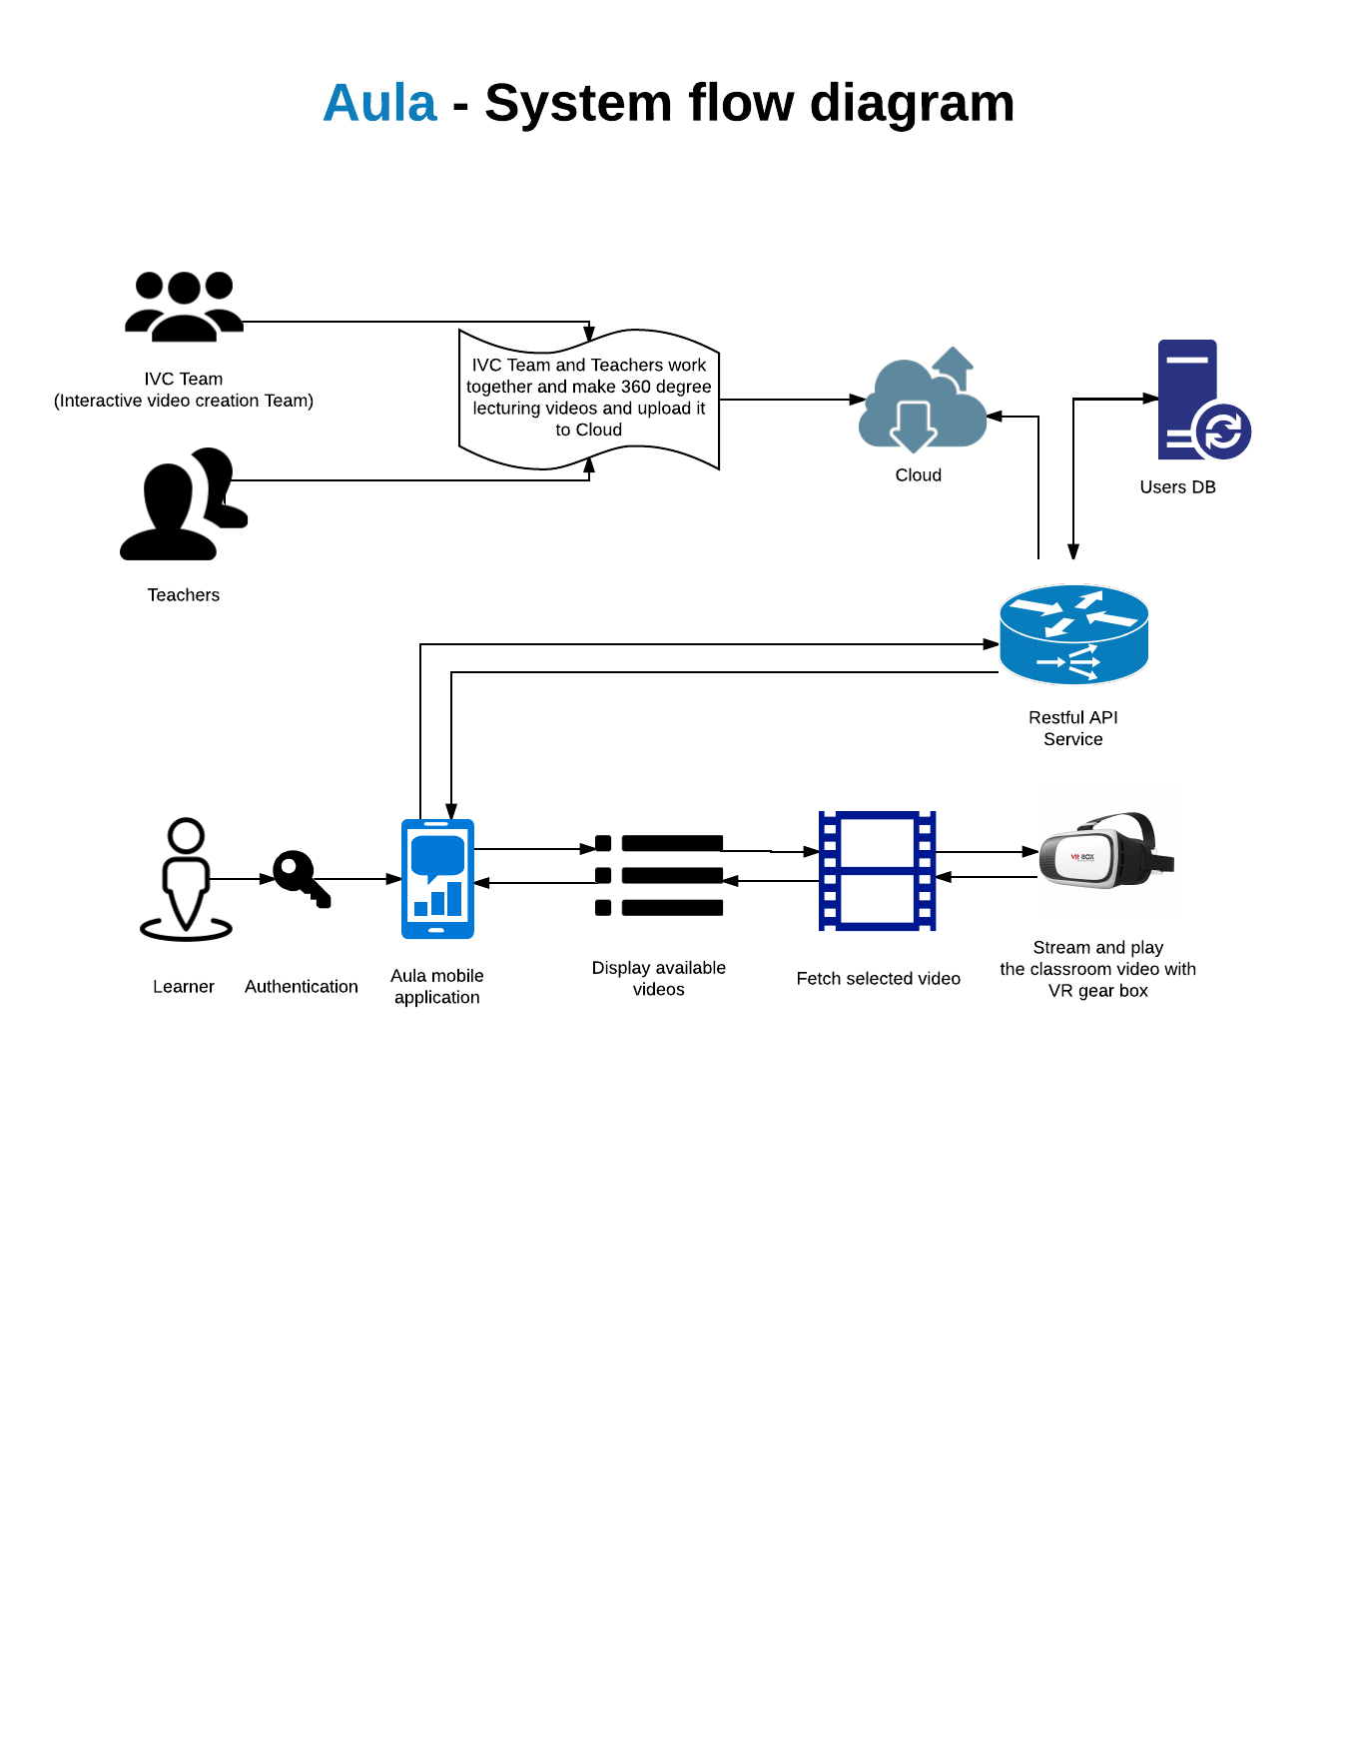**System flow diagram**

**High level flow**

1. 360 degree lecturing video is taken by Teacher & IVC team and uploaded to Cloud
2. RESTFul API service will be an endpoint for mobile client.
3. Subscribed learners logs in to Aula app
4. Learners can view the desired lecture by wearing a VR box.

**Wireframe design**

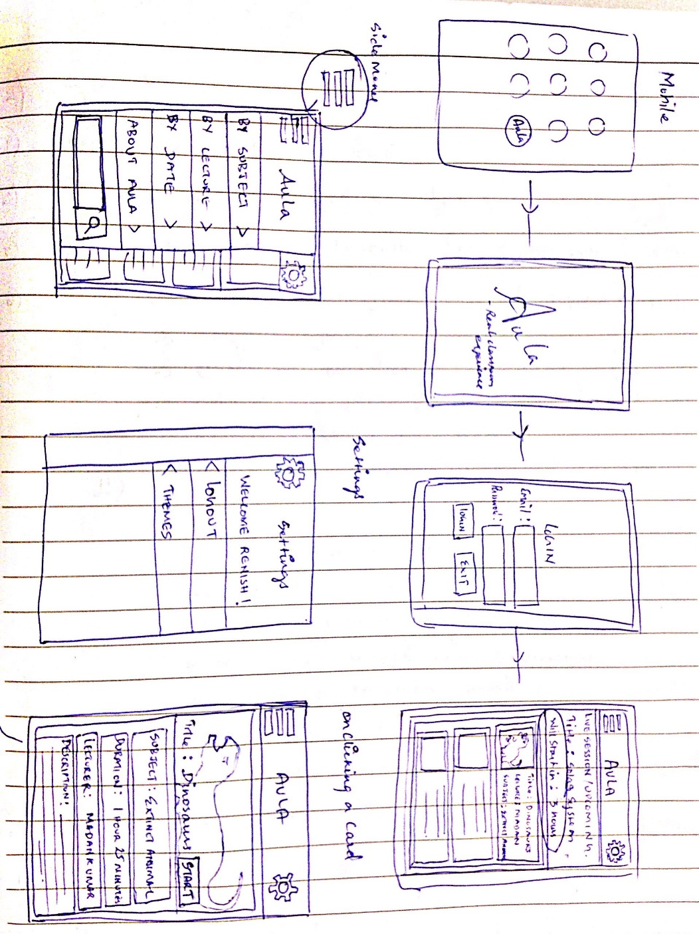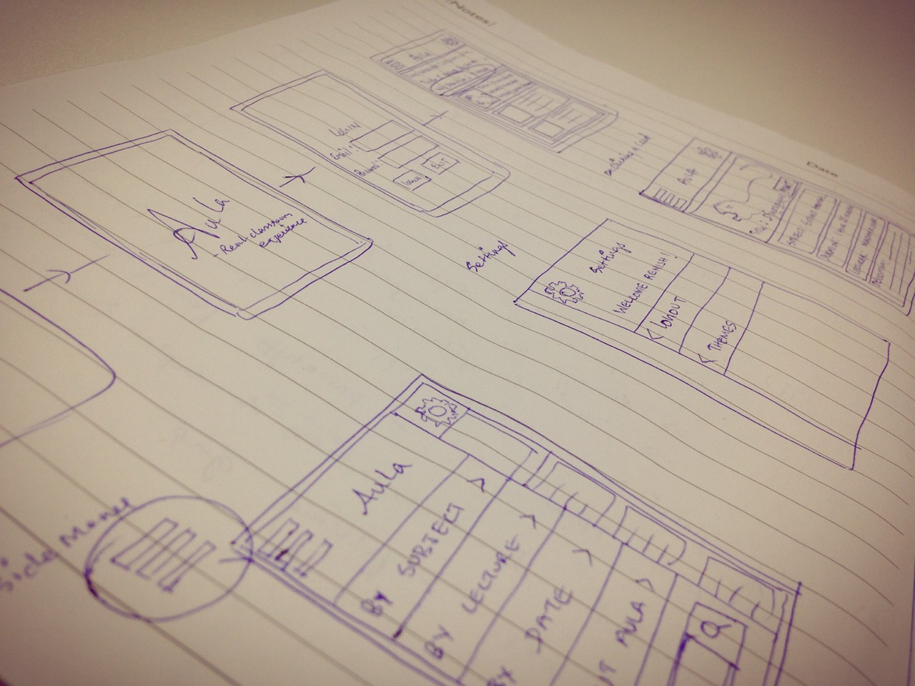

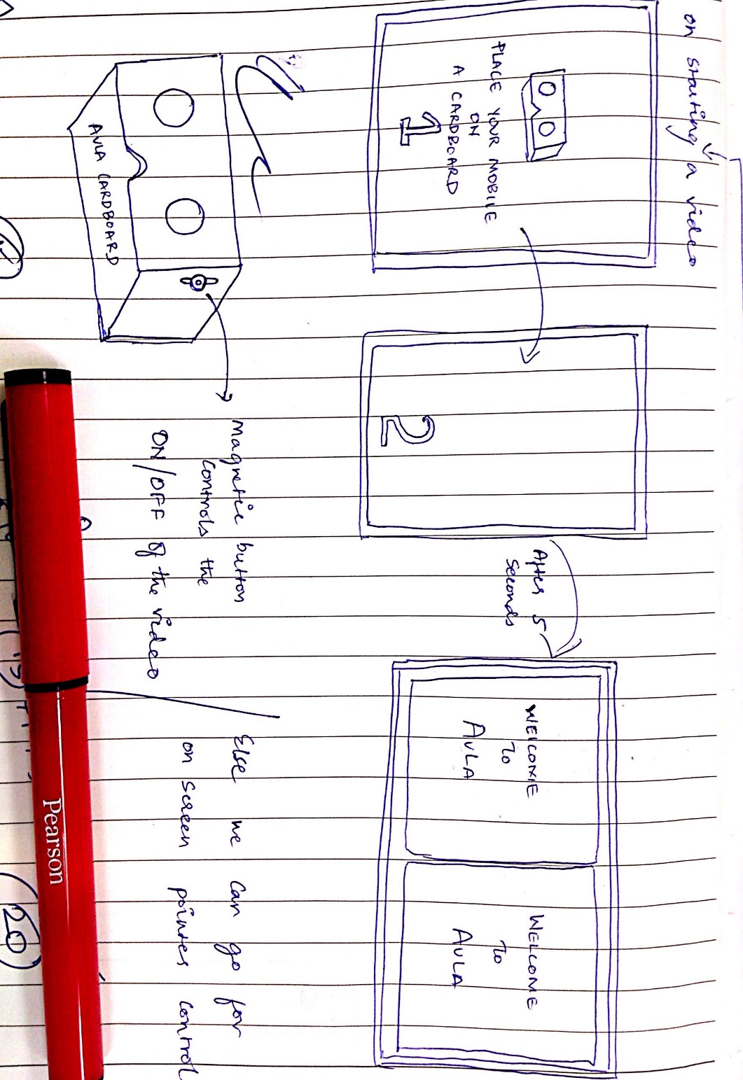

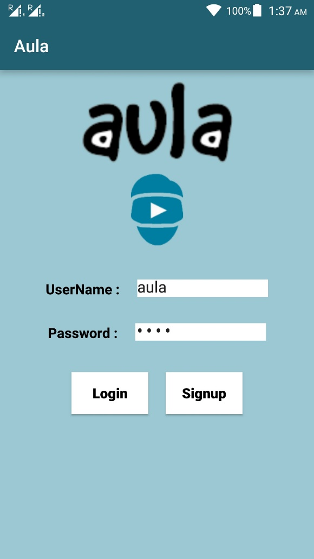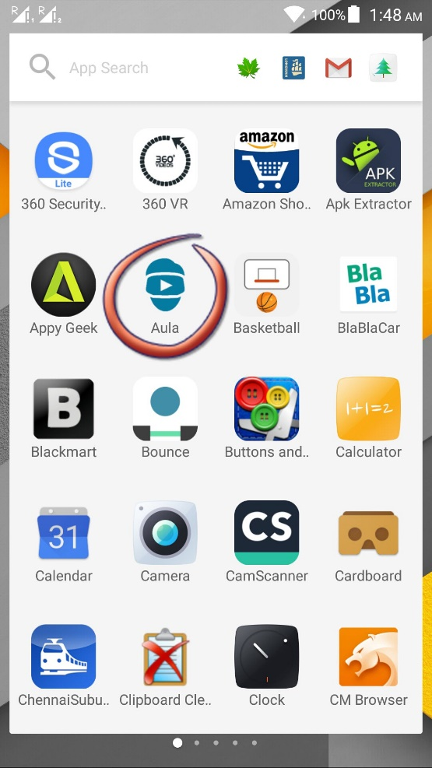**Mobile Application**

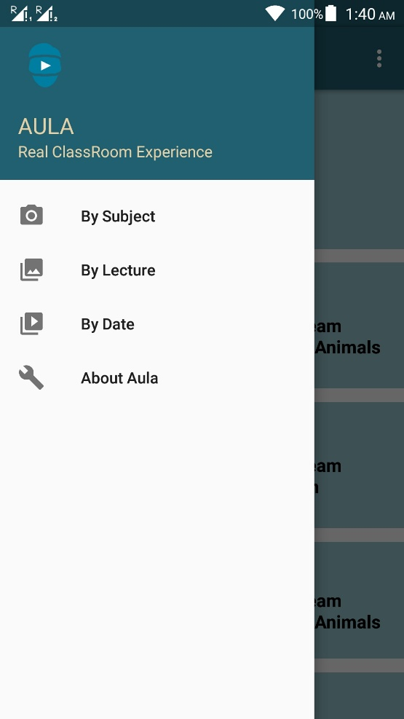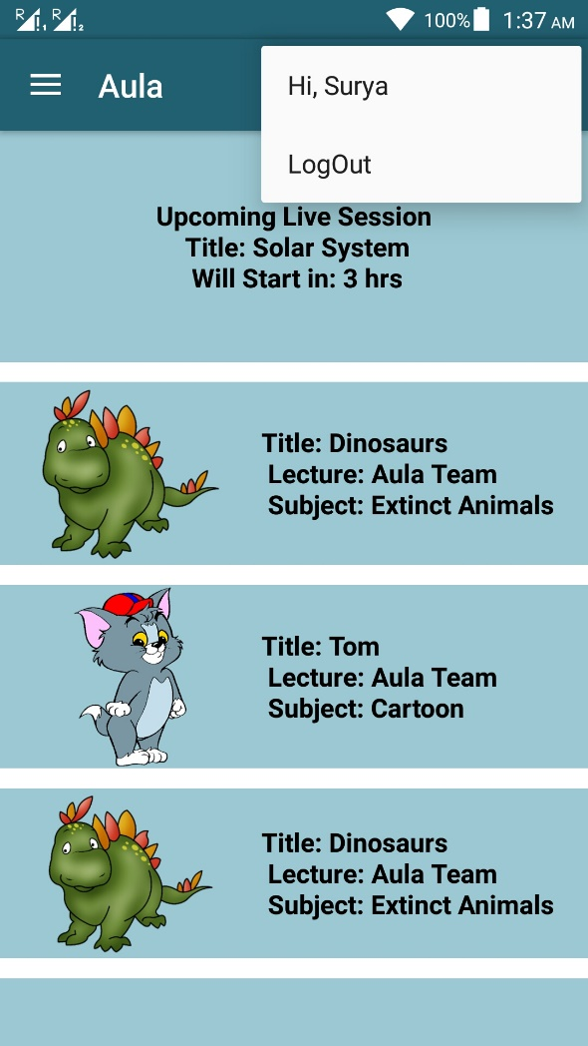

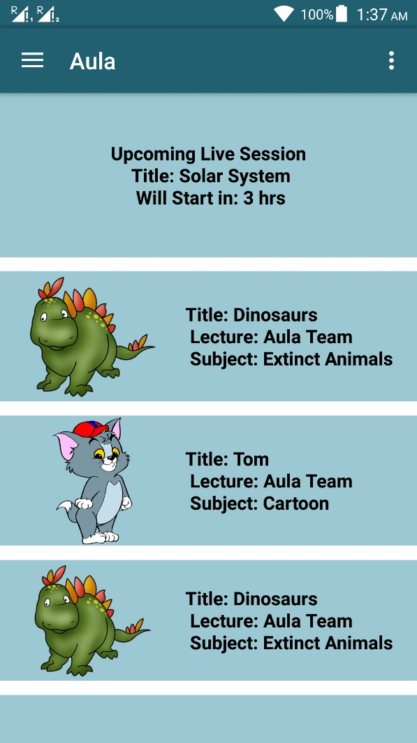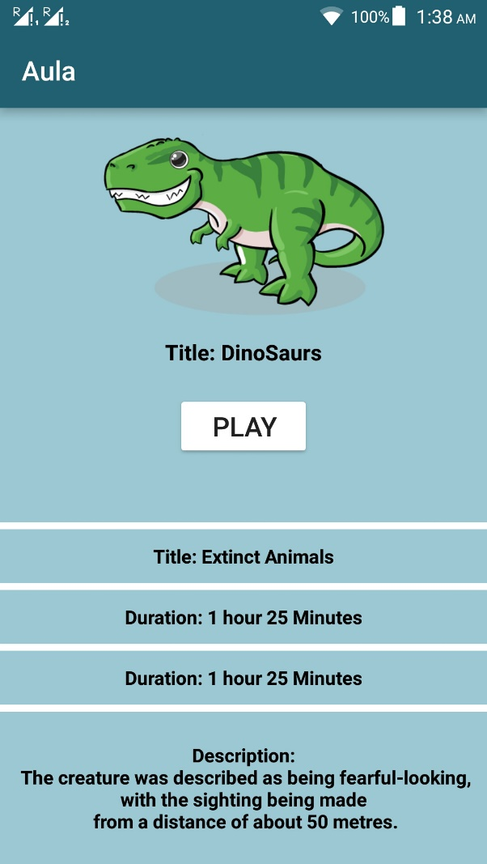

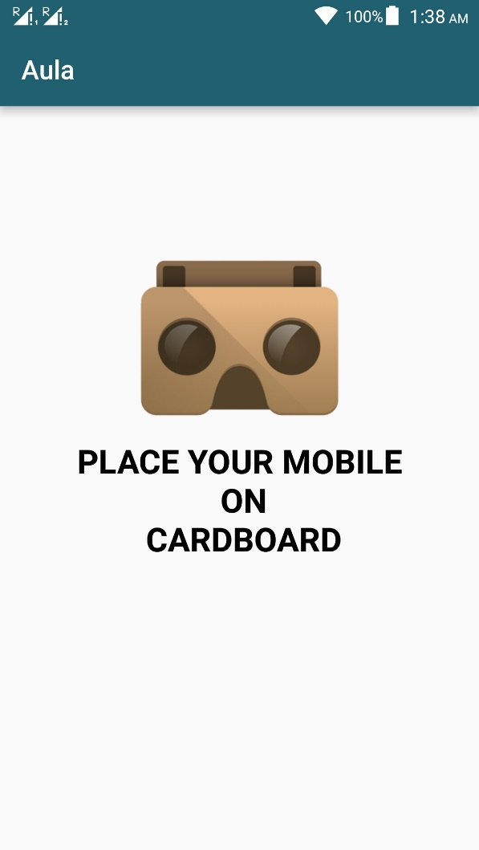

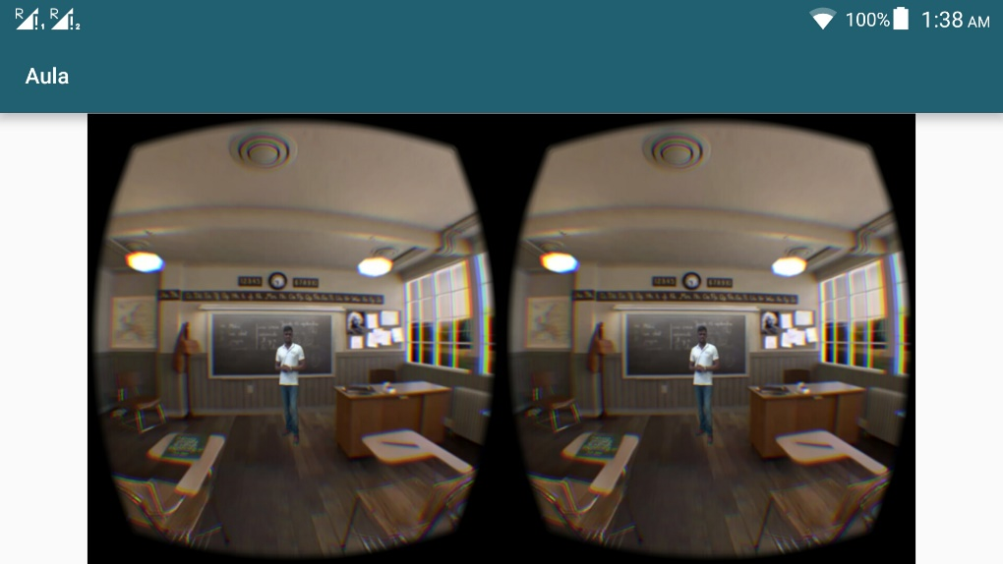

**Demo 360 degree video**

* As of now, lecture video is merged with 360 degree video
* In real, using 360 degree camera, videos can be taken effortlessly
* <https://drive.google.com/a/pearson.com/file/d/0Byi67ONvsCFdZXpvdXl5VUdMNDQ/view>

**Future enhancement**

* Online live streaming of classes
* Augmented reality can be applied
* Student-teacher interactions

**References**

* <https://www.youtube.com/watch?v=T_jOC19K5ro>
* <https://www.youtube.com/watch?v=MVwDiiJILdc>
* <https://en.wikipedia.org/wiki/Dinosaur>

Thanks for the opportunity!